Team 5
1. How many floors are there in recreation centre of Jelgava?
2. How many machineguns can be found near Academia Petrina?
3. How many platforms are there in the bus terminal of Jelgava?
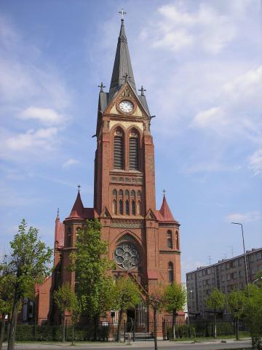
4.What is in the courtyard of church?

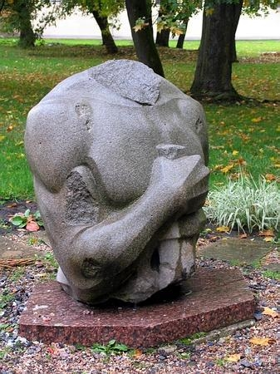
5. What can you find near this monument (café)

