Team 4
1. Find this place and make a photo !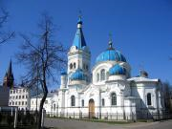
2. There are human pictures on the wall of “Academia Petrina”. Take a photo of them.
3. Where can you find this place? 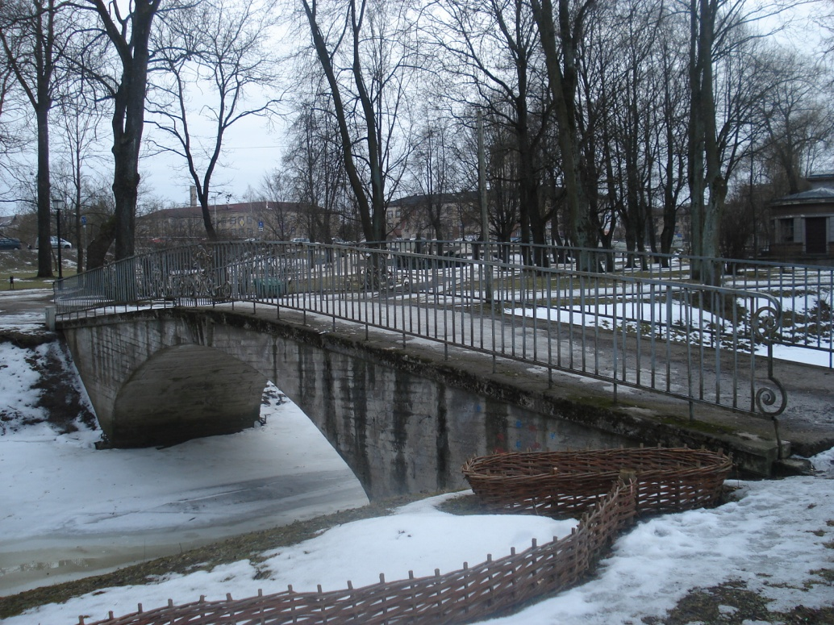

4. Make a full photo. 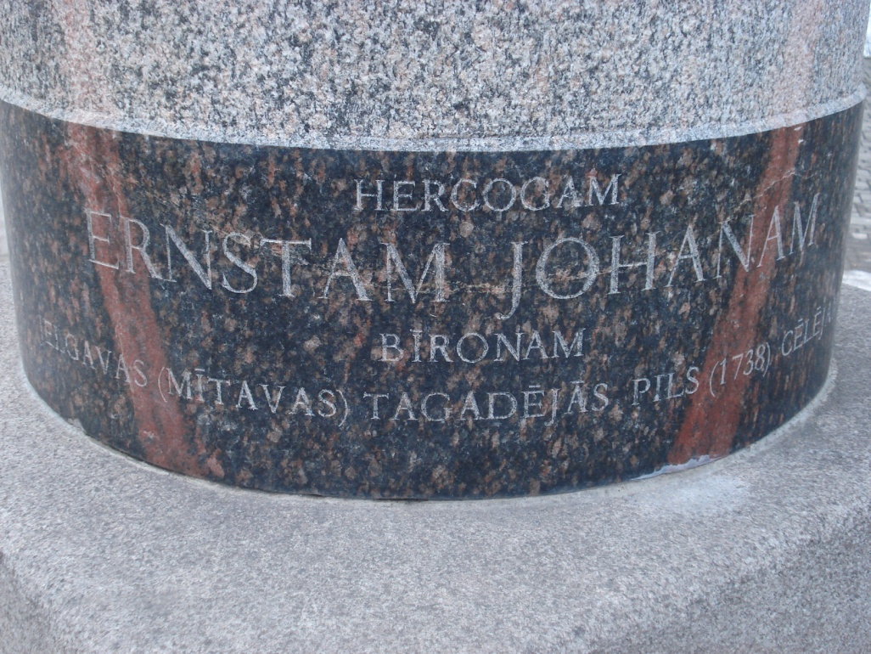
5. There is the Faculty of forest near the” Academia Petrina” (museum). And there is an interesting figure. Make a photo of it.

