Team 3
1. How many flagpoles are there by Jelgavas council? And which flags hang there?
2. Make a photo of A.Čakste’s monument.
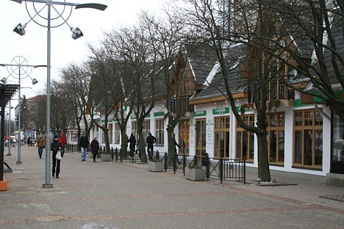
3.What is in the opposite side of the Silvas cafe?
4.What is inside the old post building of Jelgava now?
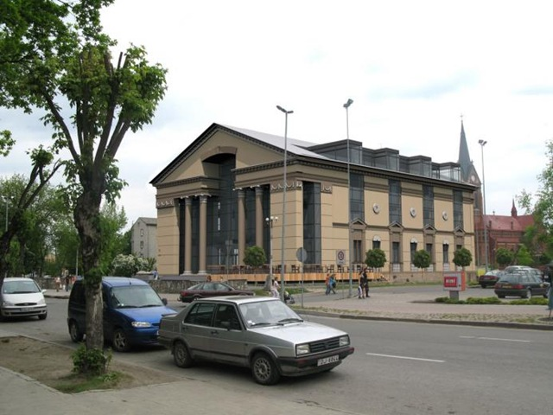
5. What was this building before the reconstruction

