Team 2

1.Where can you find this tablet? 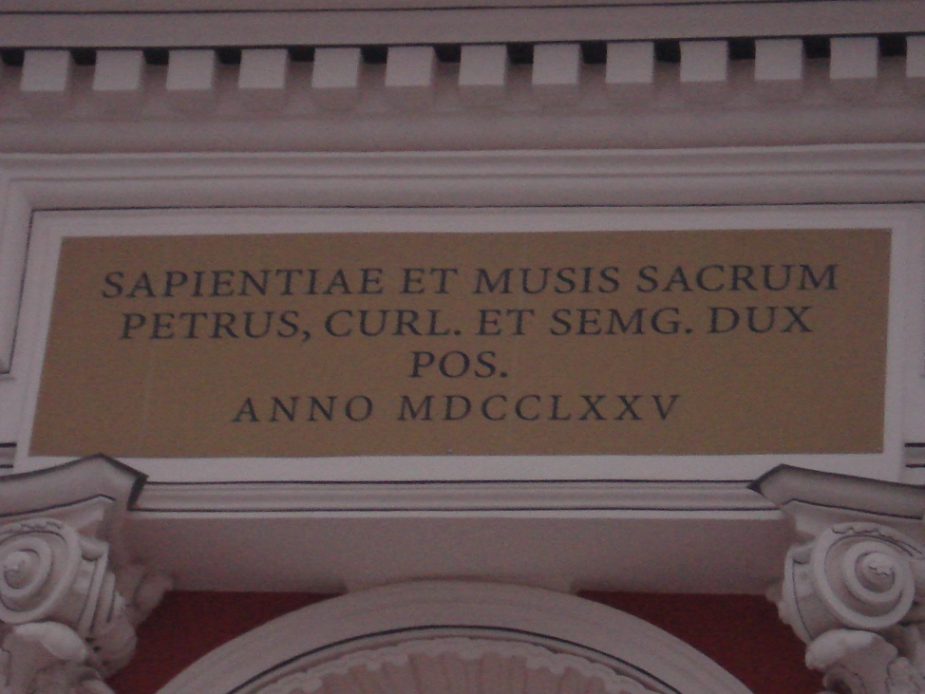

2. In what colour is this building now?
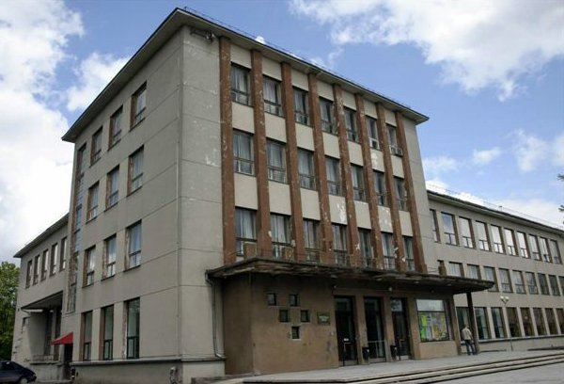

3. What monument is in “Raiņa park” ?

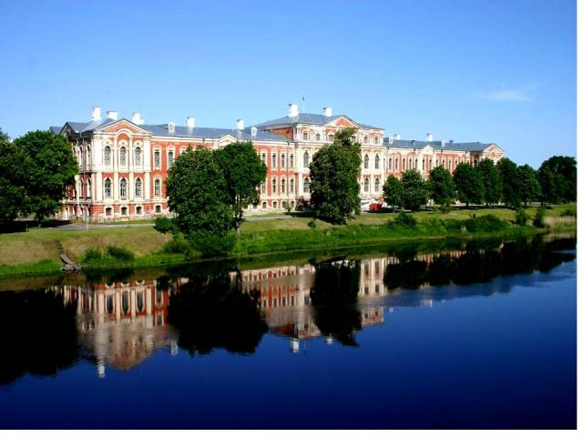
4. What is situated in this palace?

5. How many cafés are there in Jelgavas recreation centre?
