Team 1
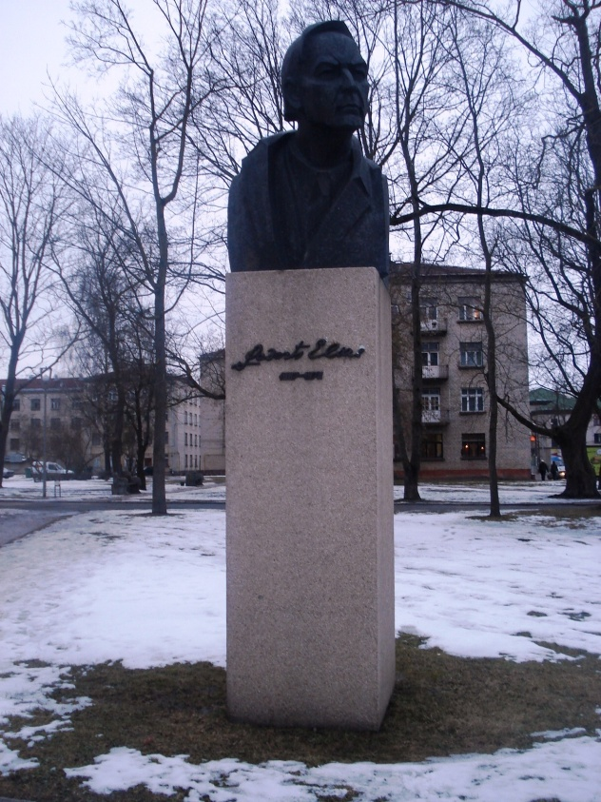1. Where is this monument?
2. Where can you find this tablet? Find it and make a photo. 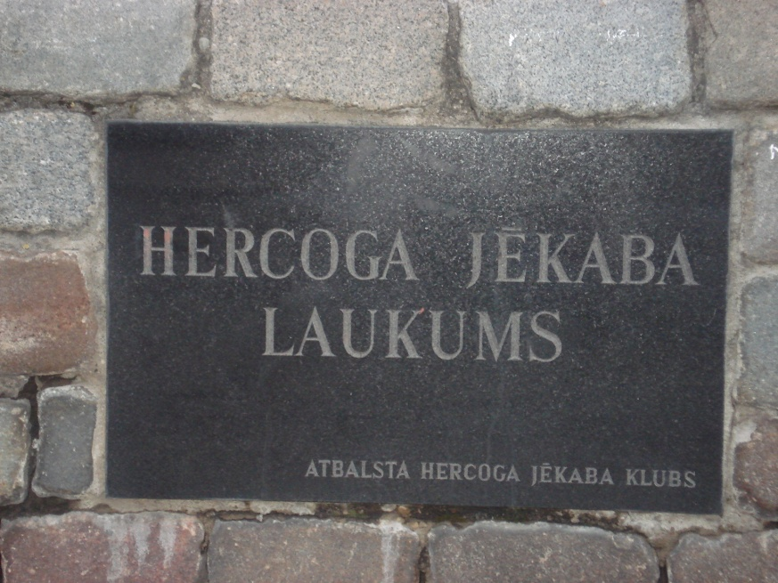
3. How many platforms are there in the bus terminal of Jelgava?
4. Who was Jānis Čakste?
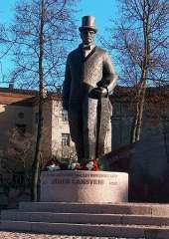
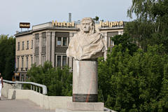5. How called is the bridge near this monument, take a photo of that bridge?

