 | ES Mūžizglītības programmas  Comenius apakšprogrammas  Divpusējās partnerības projekts  „Studēt vai strādāt? Palikt vai aizbraukt?”  Līguma nr. 2012-1-LV1-COM07-03497 1 |  | 

Workshop: Letter to the teacher
Dear Ingrida!

We want to thank you for this amazing (beautiful) opportunity. Getting to visit this beautiful (ugly) country is a fun (good) experience. We have travelled a long (bad) way. When we arrived, the weather was cold (wonderful) and rainy (orange). We have very interesting (attractive) activities. The student hosts are very friendly (naughty) and welcoming (crazy). All of this was possible because of your big (wise) kindness. We like Latvia because they have more funny (big) things to do. We are having a good (little) time, even though our feet hurt really badly (loudly). Some of the activities were weird (short) but at the weekends we had a lot of fun (interesting). Riga is a very beautiful (extraordinary) place with a lot (careful) of amazing (funny) attractions. We are lucky (talkative) students because we had the opportunity to meet such a lovely (sleepy) person like you.
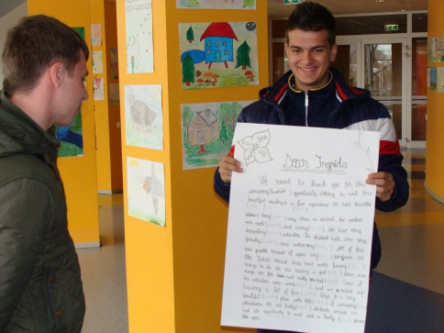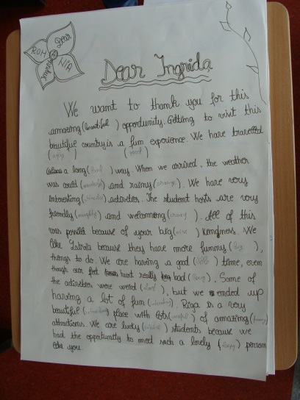
(Romanian students)

Lovely (Red) Ingrida!

Thank you for understanding (white)! We had so much tubby (small) moments and that is all thanks to this project and you! You have given us a wonderful (tall) opportunity to experience going to another country and meeting new interesting (fat) people! And a big (thin) thank you for being the best (yellow) teacher. You organized awesome (big) excursions, class parties and just understood (little) us; we know how hard it can be with teenagers.
So all of us are saying a BIG THANK YOU for being awesome!
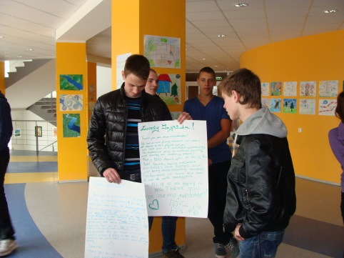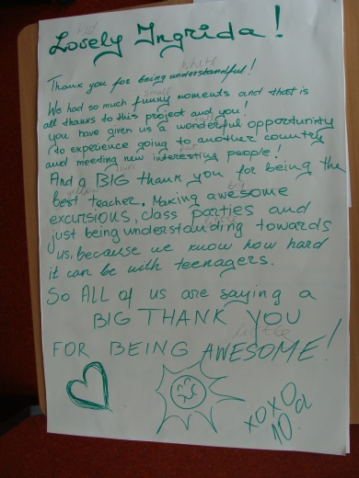

(Latvian students)

