Group 1.
1.What happened with this castle in the World War II ?
___________________________________________
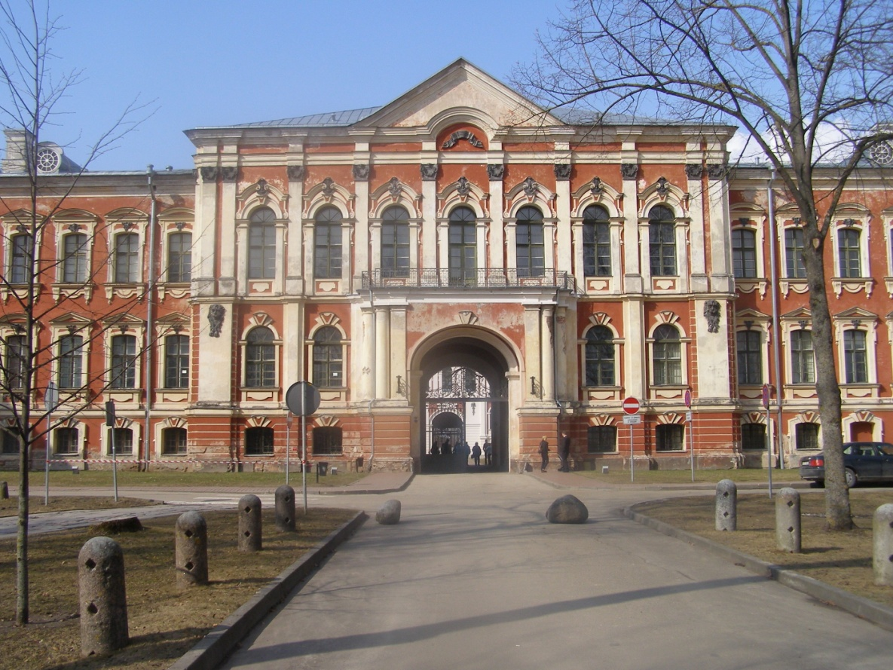Time:______________
2.What is this object?
_____________________________________________
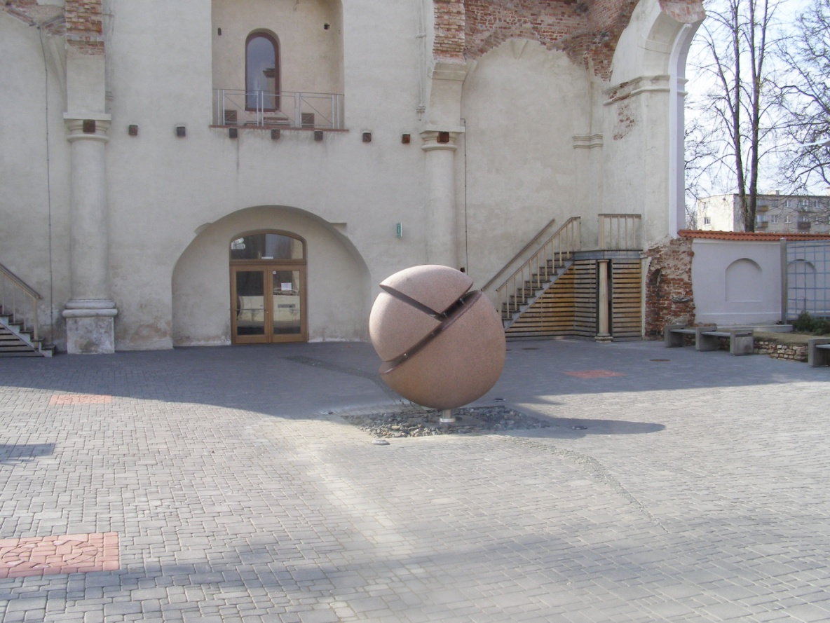Time:________________
3.What’s the name of this building?
______________________________________________
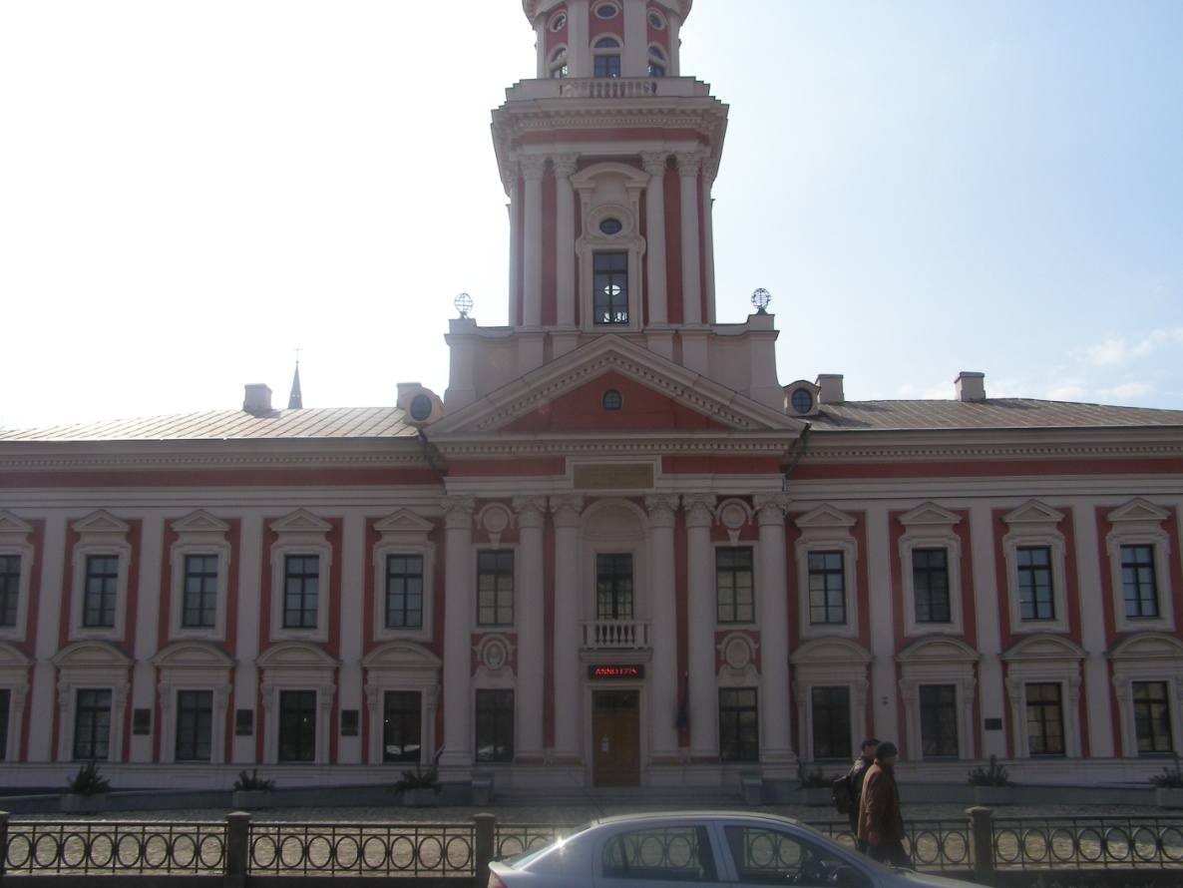Time:_______________
 | ES Mūžizglītības programmas  Comenius apakšprogrammas  Divpusējās partnerības projekts  „Studēt vai strādāt? Palikt vai aizbraukt?”  Līguma nr. 2012-1-LV1-COM07-03497 1 |  |  | 

4.What kind of sports field is near by the school?
_____________________________________________________
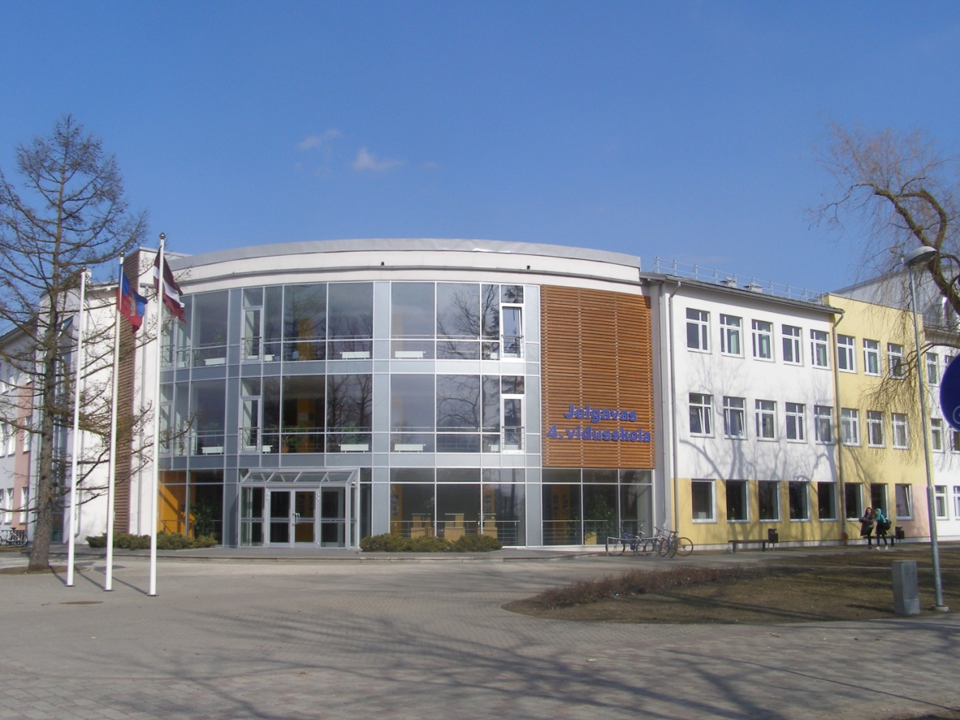Time:___________________
5.What kind of sports field is in the back of this hotel?
_____________________________________________________
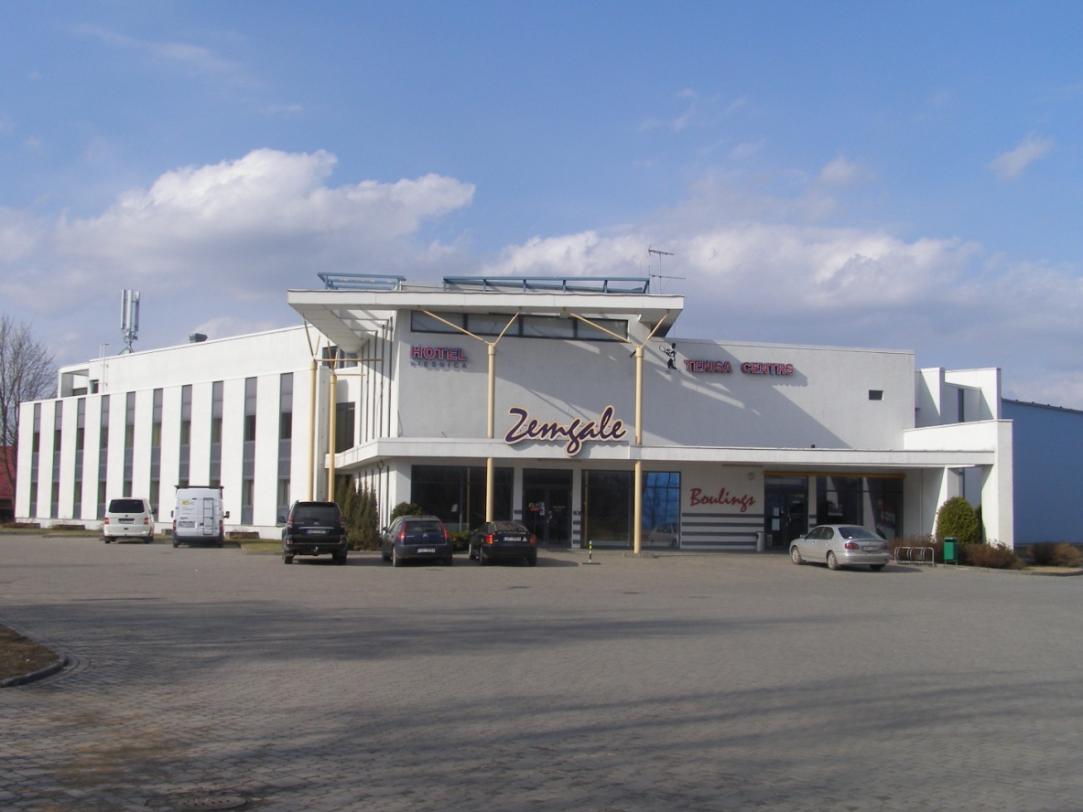Time:___________________
Find the object in Jelgava!
Take a picture together with your group in front of the object!
Answer the question!
Write the time of the taking of Picture!

