Group 5
- What is this object and where can you find it?____________________________________
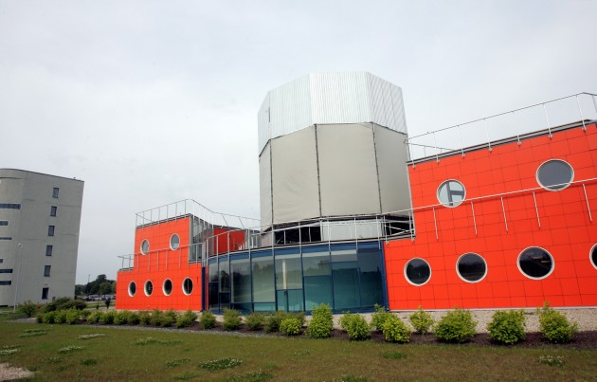Time:______________
2. Which “Holy Trinity Church Tower” clock digit is different than others? (one of them is gold plated)
_____________________________________________
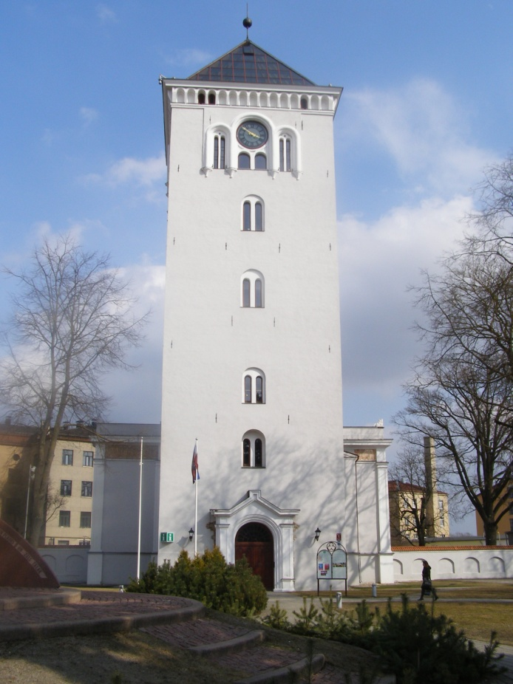Time:_______________
3. Name of restaurant which is opposite side of street this church?
____________________________________________
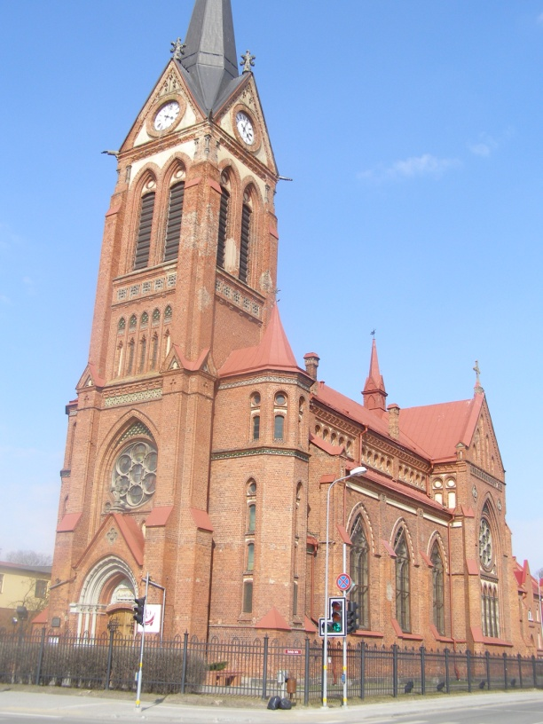Time:_______________

 | ES Mūžizglītības programmas  Comenius apakšprogrammas  Divpusējās partnerības projekts  „Studēt vai strādāt? Palikt vai aizbraukt?”  Līguma nr. 2012-1-LV1-COM07-03497 1 |  |  | 

4. What is name of the bank which is situated in this building?
_____________________________________________________
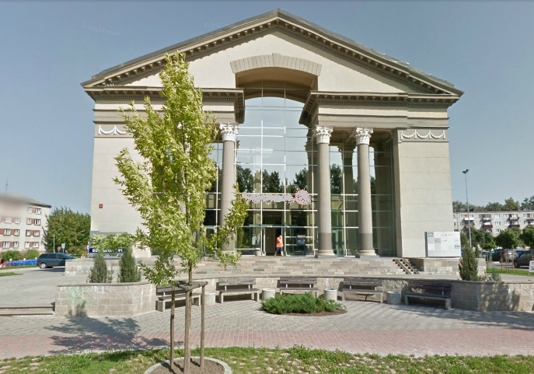Time:___________________
5. What kind of activity you can do near the Jelgavas BMX track?
_____________________________________________________
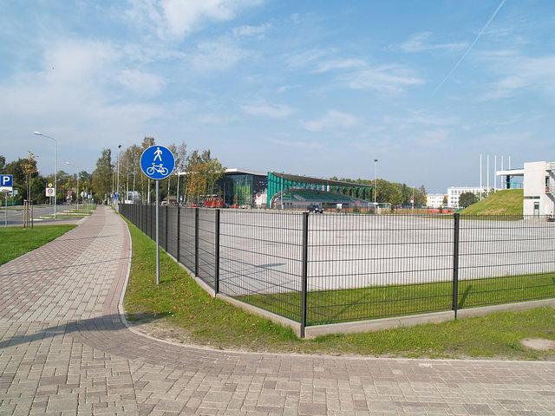Time:___________________
Find the object in Jelgava!
Take a picture together with your group in front of the object!
Answer the question!
Write the time of the taking of Picture!

