Group 4
- Name of the river?
____________________________________
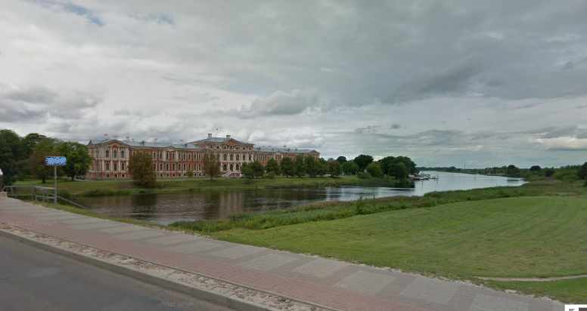Time:______________
2. What is this building?
_____________________________________________
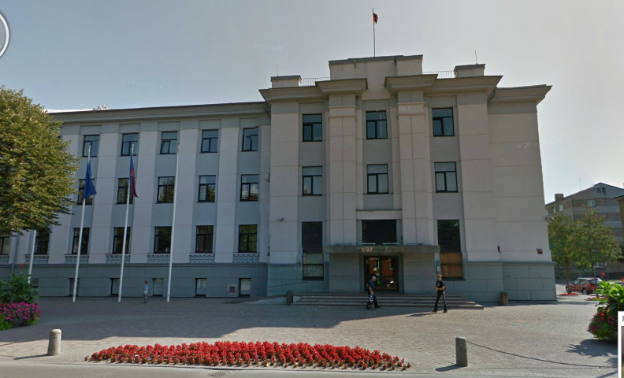Time:_______________
3. What is name of shop next to this house? (right side)
____________________________________________
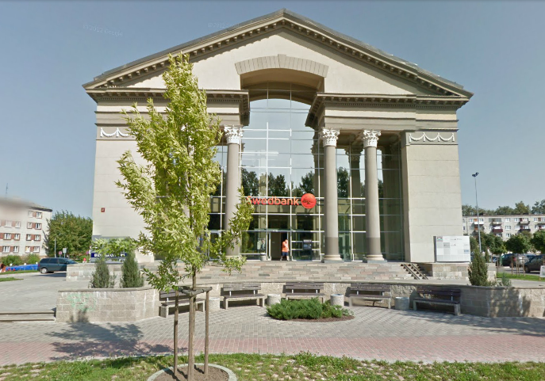Time:_______________

 | ES Mūžizglītības programmas  Comenius apakšprogrammas  Divpusējās partnerības projekts  „Studēt vai strādāt? Palikt vai aizbraukt?”  Līguma nr. 2012-1-LV1-COM07-03497 1 |  |  | 

4. Who is this person? (name)
_____________________________________________________
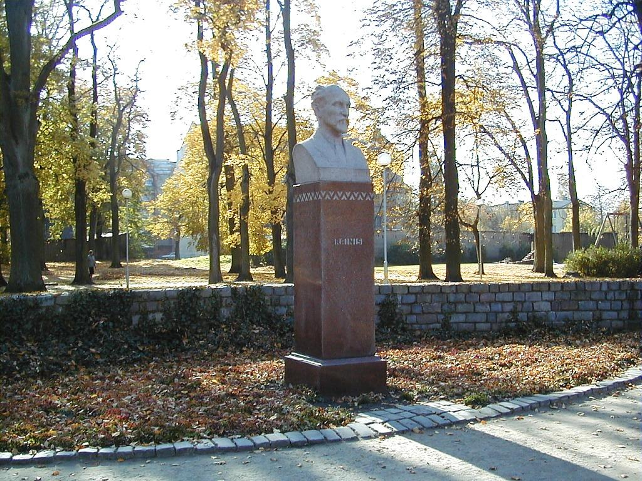Time:___________________
5. Take a photo of monument which is opposite to Jelgava train station.
_____________________________________________________
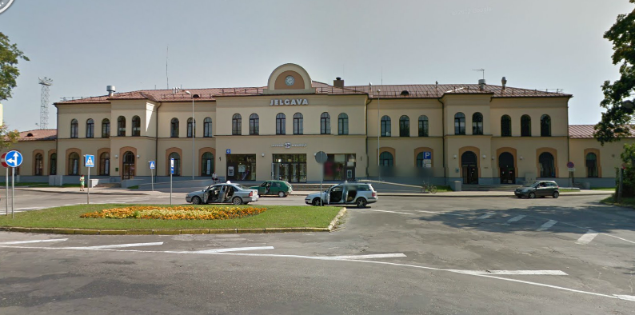Time:___________________
Find the object in Jelgava!
Take a picture together with your group in front of the object!
Answer the question!
Write the time of the taking of Picture!

