Group 3
- In which year this tower was restored?
___________________________________________
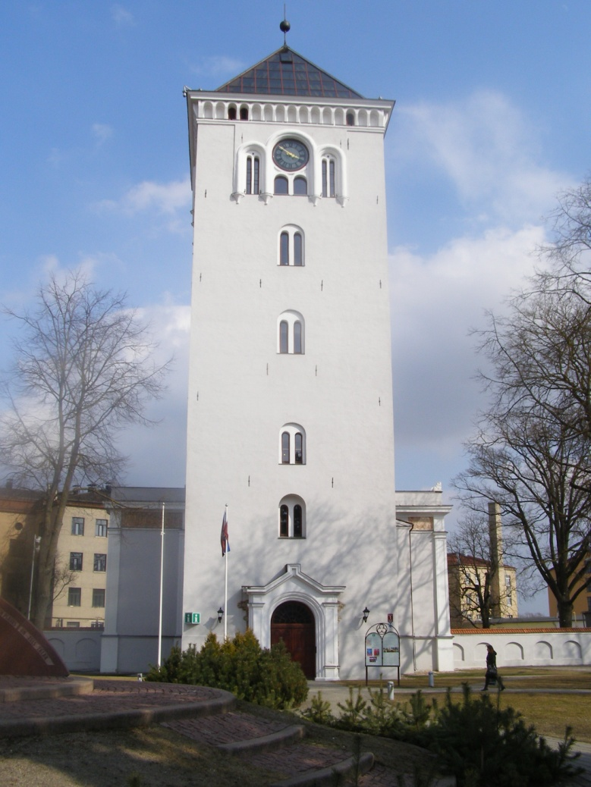Time:______________
2. What’s the name of this church?
_____________________________________________
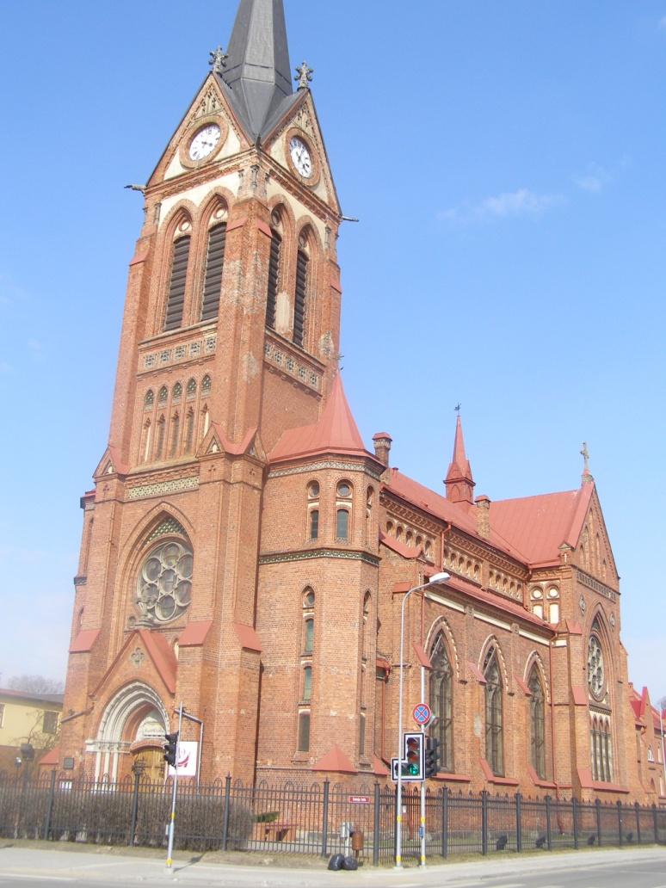Time:_______________
3. Why this building is very special for Jelgava?
____________________________________________
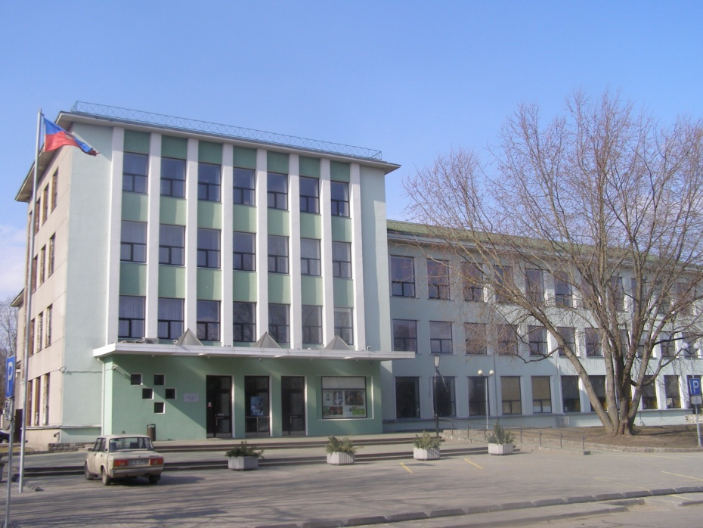Time:_______________
 | ES Mūžizglītības programmas  Comenius apakšprogrammas  Divpusējās partnerības projekts  „Studēt vai strādāt? Palikt vai aizbraukt?”  Līguma nr. 2012-1-LV1-COM07-03497 1 |  |  | 

4. What’s the short name of this Olympic centre?
_____________________________________________________
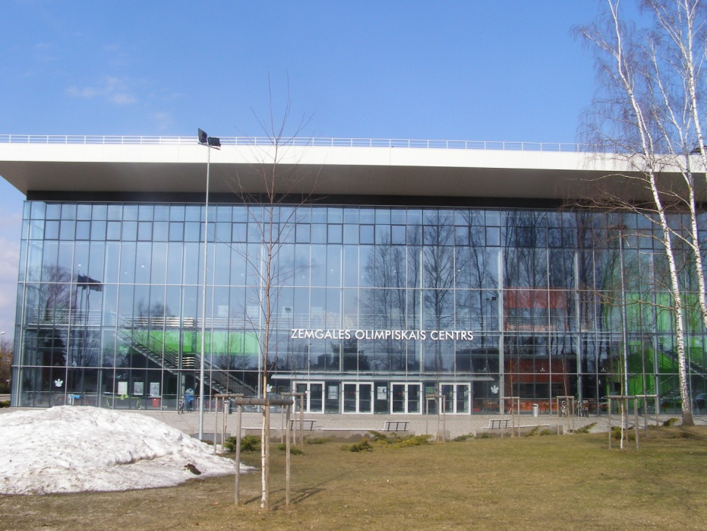Time:___________________
5. What’s the name ot the hockey team which plays in this hockey arena?
_____________________________________________________
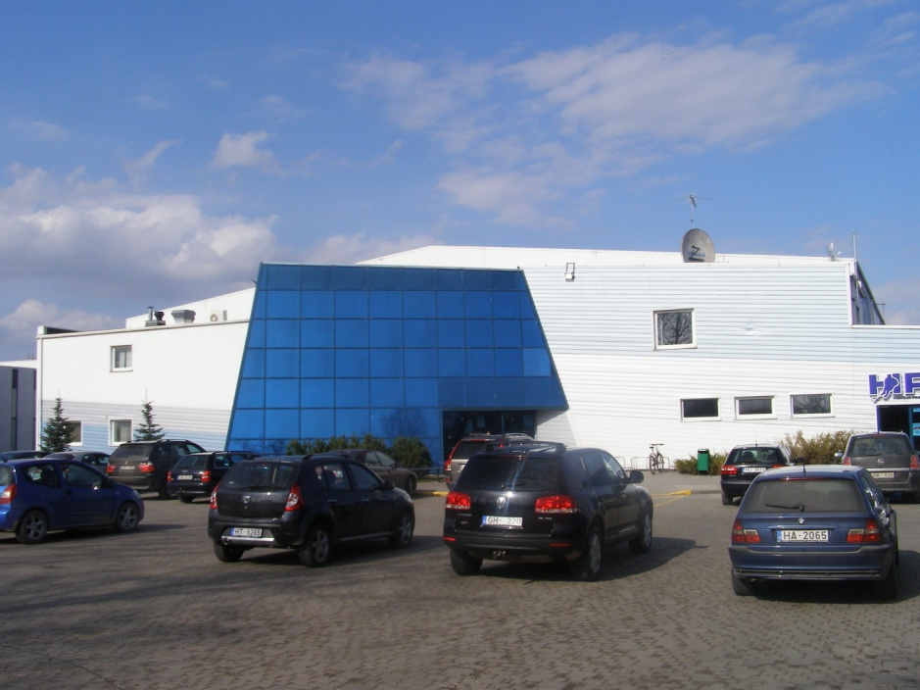Time:___________________
Find the object in Jelgava!
Take a picture together with your group in front of the object!
Answer the question!
Write the time of the taking of Picture!

