Group 2
1. What’s the name of this bridge? ___________________________________________
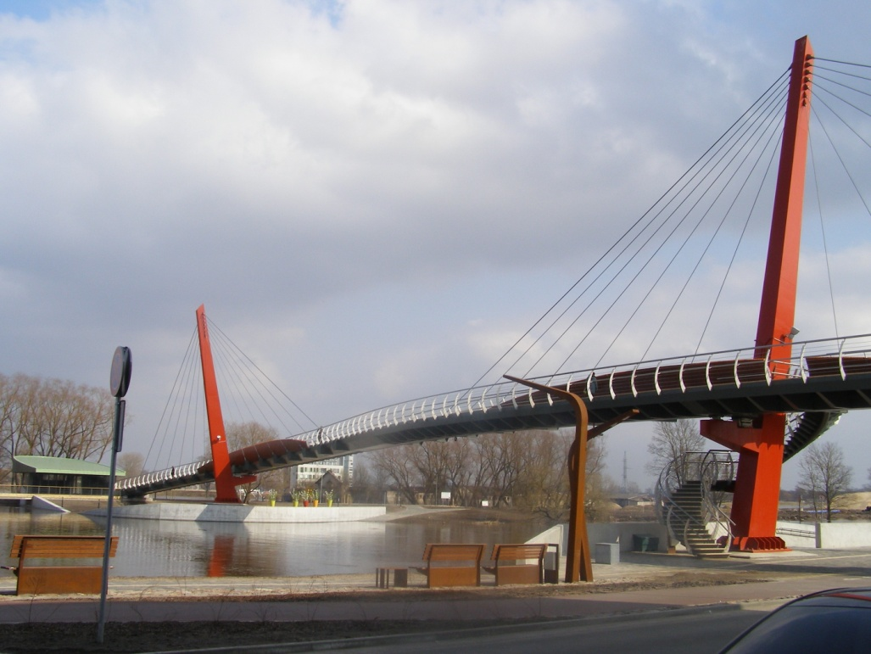Time:______________
2. Who was this man?
_____________________________________________
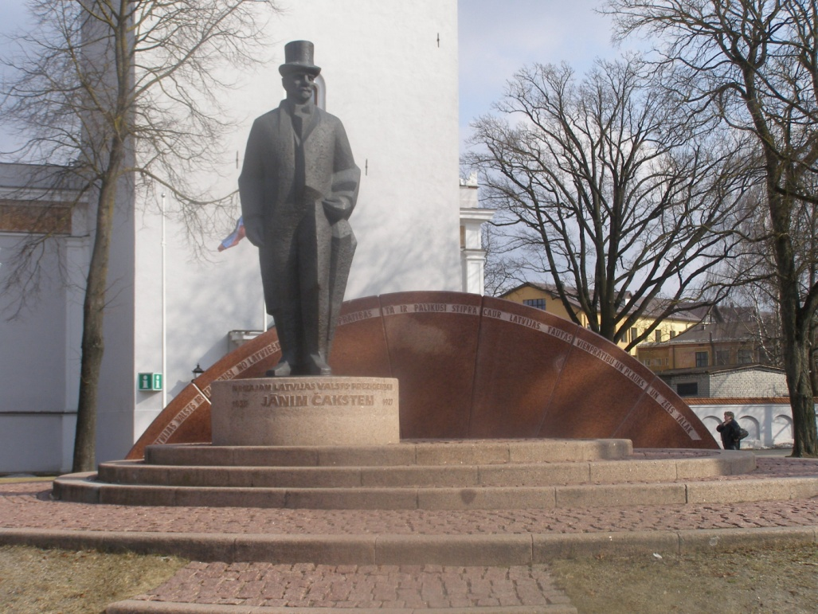Time:________________
3. .How many crosses have thichurch?
____________________________________________
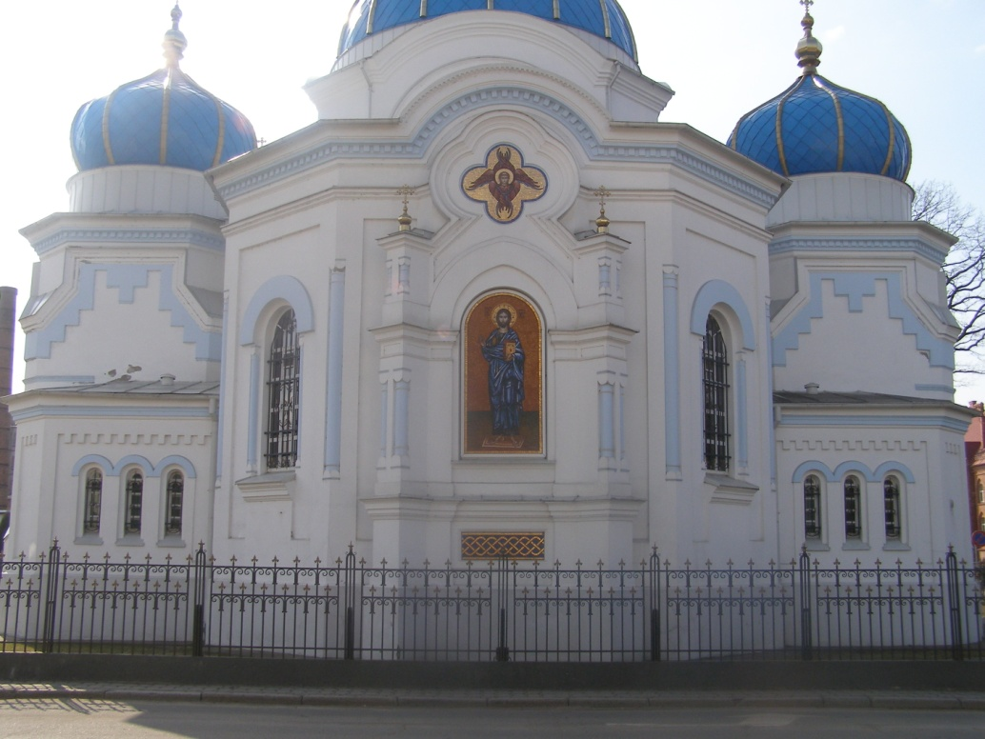Time:_______________
 | ES Mūžizglītības programmas  Comenius apakšprogrammas  Divpusējās partnerības projekts  „Studēt vai strādāt? Palikt vai aizbraukt?”  Līguma nr. 2012-1-LV1-COM07-03497 1 |  |  | 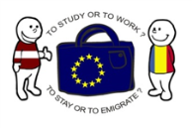

4. What’s the name of the market that’s beside this statue?
_____________________________________________________
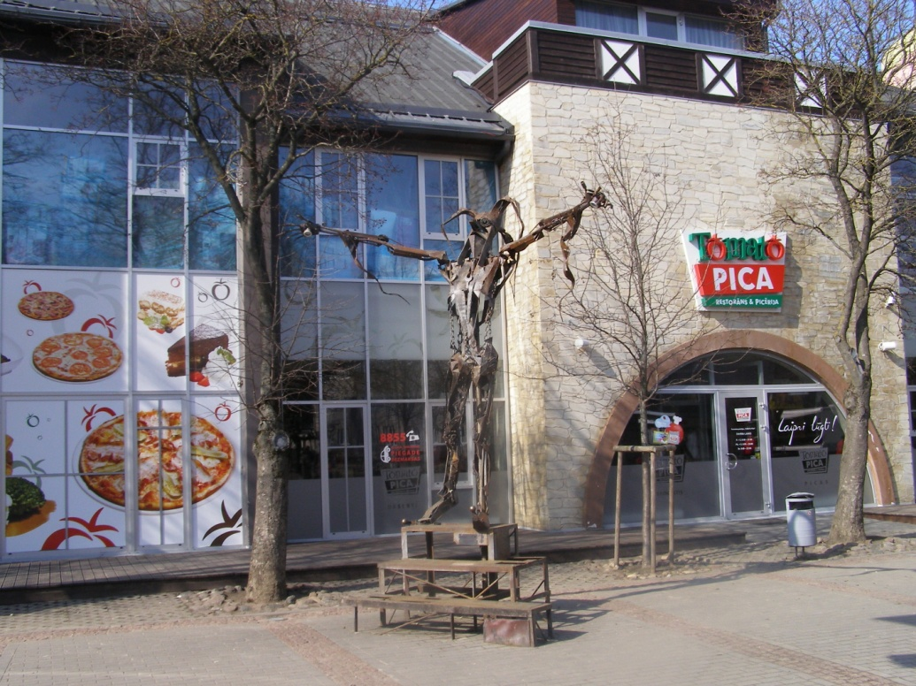Time:___________________
5. In which year the McDonald’s was opened?
_____________________________________________________
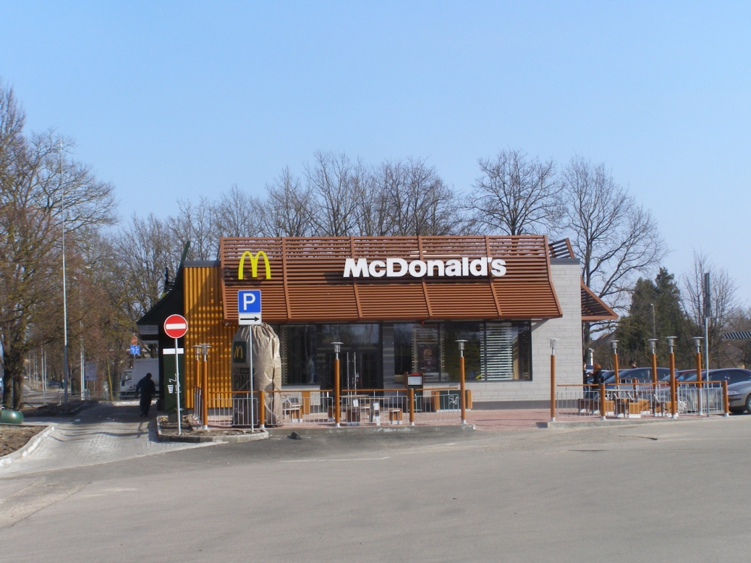Time:___________________
Find the object in Jelgava!
Take a picture together with your group in front of the object!
Answer the question!
Write the time of the taking of Picture!

