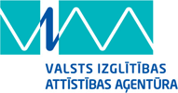 | ES Mūžizglītības programmas  Comenius apakšprogrammas  Divpusējās partnerības projekts  „Studēt vai strādāt? Palikt vai aizbraukt?”  Līguma nr. 2012-1-LV1-COM07-03497 1 | 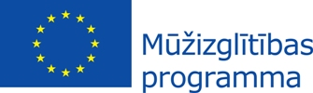

The LOGO results from Romania and Latvia are:
 | ROMANIA | LATVIA | ROMANIA +LATVIA
Nr 1 | 12.1% | 43.8% | 55.9%
Nr 2 | 3.4% | 11.3% | 14.7%
Nr 3 | 56.2% | 26.3% | 82.5%
Nr 4 | 15.4% | 3.8% | 23%
Nr 5 | 0.6% | 0% | 0.6%
Nr 6 | 26.6% | 15% | 41.6%

1st place - Sintija Ločmele (LV)
2 nd place – Sandijs Bečis (LV)
3rd place – Romania

Project LOGO is:
